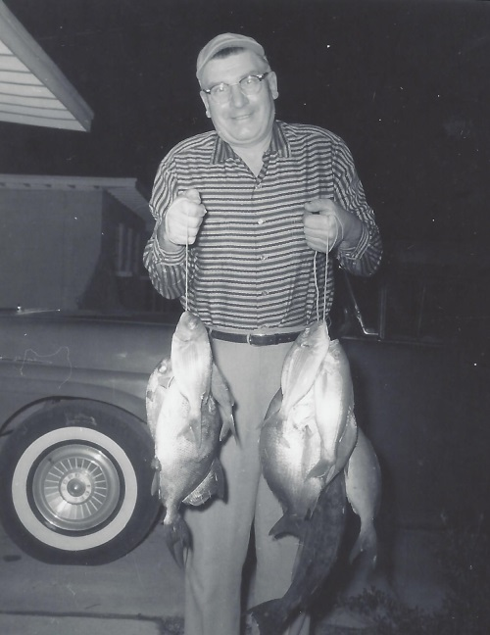

Russell F. Wolfe with fish – about 1959 (est.)

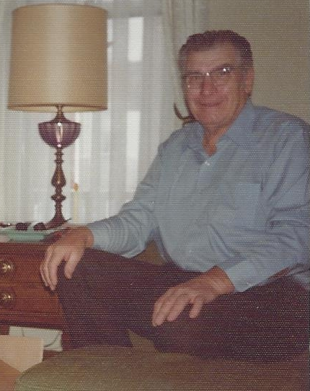

Russell Franklin Wolfe – about 1960 (est.)